**Questions 1.** A retirement account is opened with an initial deposit of $8,500 and earns 8.12% interest compounded monthly. What will the account be worth in 20 years? What if the deposit was calculated using simple interest? Could you see the situation in a graph? From what point one is better than the other?

**Solution:**  
  
**Compound Interest:** The formula for compound interest is given by **A = P(1 + )nt**, where:

* *A* is the future value,
* *P* is the principal amount,
* *r* is the annual interest rate (as a decimal),
* *n* is the number of times interest is compounded per year,
* *t* is the time the money is invested for in years.

**In this case:**

A = 8500 (1 + )12X20

A ≈ 8500×4.728

**A ≈ 40,188.33**

**Simple Interest:** The formula for simple interest is ***A* = *P* (1 + *rt*).**

**In this case:**

A = 8500 × (1 + 0.0812 × 20)

*A* ≈ 8500 × 2.624

***A* ≈ 22,409.49**

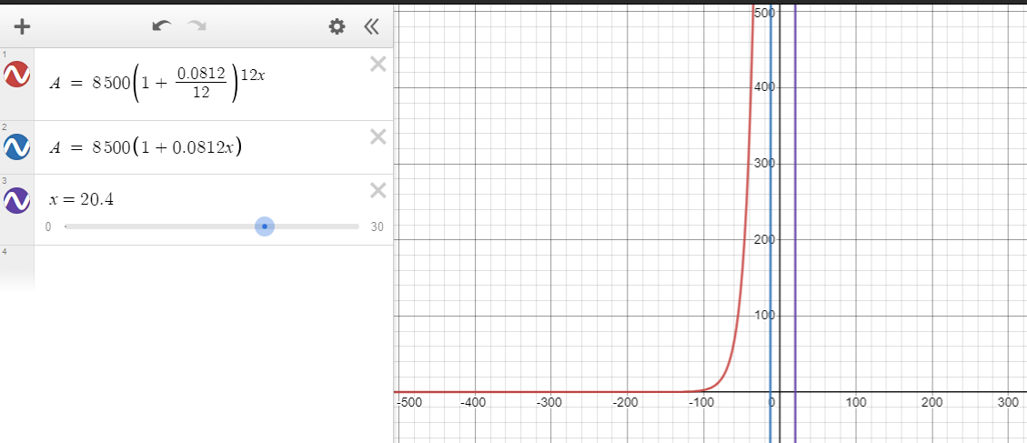

**Question 2.** Graph the function [ f(x)=5(o.5)^{-x} ](https://my.uopeople.edu/filter/tex/displaytex.php?texexp=%20f(x)%3D5(o.5)%5e%7b-x%7d%20) and its reflection about the line y=x on the same axis, and give the x-intercept of the reflection. Prove that [ a^x=e^{x lna} ](https://my.uopeople.edu/filter/tex/displaytex.php?texexp=%20a%5ex%3De%5e%7bx%20lna%7d%20). [Suggestion: type [ y=5(0.5^{-x}) ](https://my.uopeople.edu/filter/tex/displaytex.php?texexp=%20y%3D5(0.5%5e%7b-x%7d)%20) {- 7 < x < 2}  {0 < y < 7} in desmos, and then type its inverse function.]

**Solution:**

**Graph of *f*(*x*) and its Reflection:**

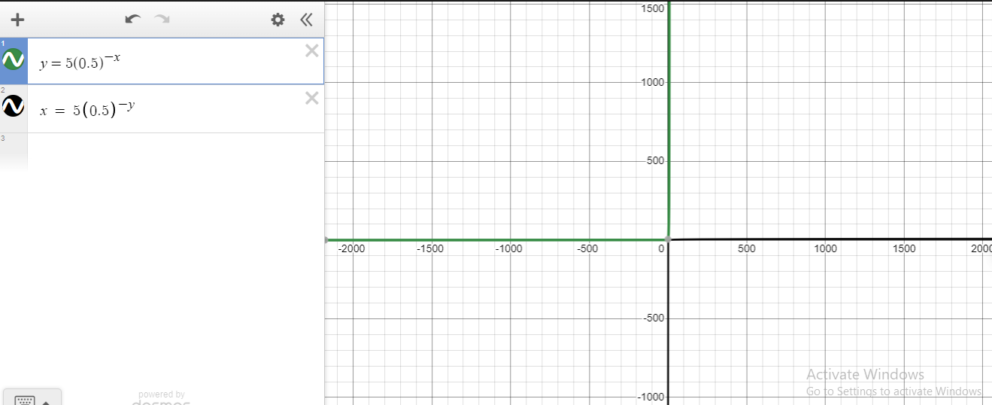  
  
**X-intercept of the Reflection:**

* Set y=0 and solve for *x*.
* The x-intercept is the solution to the equation **0 = 5(0.5)-x.**

**Proving ax = e  ln(a):**

ax = e ln(a^x) because x ln(a) = ln (ax)

e ln(a^x) = (e ln(a))x because abc = (ab)c

(e ln(x))x = ax because e ln(x) = x

Hence Prove That **ax = e  ln(a)**

**Question 3 (Part A).**  How long will it take before twenty percent of our 1,000-gram sample of uranium-235 has decayed? [See Section 6.6 Example 13]

The decay equation is [ A(t)=A_0e^{Kt} ](https://my.uopeople.edu/filter/tex/displaytex.php?texexp=%20A(t)%3DA_0e%5e%7bKt%7d%20), where t is the time for the decay, and *K* is the characteristic of the material. Suppose *T* is the time it takes for half of the unstable material in a sample of a radioactive substance to decay, called its half-life. Prove that [ K= \frac{ln0.5}{T}  ](https://my.uopeople.edu/filter/tex/displaytex.php?texexp=%20K%3D%20\frac%7bln0.5%7d%7bT%7d%20%20) . What is *K*for the uranium-235? Show the steps of your reasoning. (T = 703,800,000 years)

**Solution:**

**Decay Equation:** The decay equation is [ A(t)=A_0e^{Kt} ](https://my.uopeople.edu/filter/tex/displaytex.php?texexp=%20A(t)%3DA_0e%5e%7bKt%7d%20) where:

* *A*(*t*) is the amount at time *t*,
* *A*0​ is the initial amount,
* *k* is the decay constant,
* *t* is time.
* T is the half-life.
* Half-life equation: k=ln (0.5)/T.
* For uranium-235, T=703,800,000 years.

**Proof for k = $\frac{ln⁡(0.5)}{T}$:**

k = $\frac{ln⁡(0.5)}{T}$

According to given question, The half-life (*T*) is the time it takes for half of the substance to decay

**A(T) = A0**

Substitute A(*T*)=​*A*0 and *T* into the decay equation

A0 = Ao ekt

= ekt

Taking ln on both side  
ln($\frac{1}{2}$) = ln(ekt)

-ln(2) = kT because ln(ab) = b ln(a)

k = $\frac{-ln⁡(2)}{T}$

**k = $\frac{0.5}{T}$**  because ln(0.5) = -ln(2)

**Finding Decay Constant *k*:**

Given ***k* = $\frac{ln⁡(0.5)}{T}$** for a half-life T =703,800,000 years:

K = $\frac{ln⁡(0.5)}{703,800,000}$

Now, if we want to find the time it takes for twenty percent of the uranium-235 to decay

(A(t) = 0.2 x A0 ), we can use the decay equation

0.2 x A0 = A0 ekt

0.2 = ekt

Taking ln on both side

ln(0.2) = kt

t = $\frac{ln⁡(0.2)}{k}$

since k = $\frac{ln⁡(0.5)}{T}$ and *T* is the half-life of uranium-235 (*T* = 703,800,000 years)

t = $\frac{ln⁡(0.2)}{\frac{ln⁡(0.5)}{T}}$

t = $\frac{ln⁡(0.2)T}{ln⁡(0.5)}$

t = $\frac{ln⁡(0.2)(703,800,000)}{ln⁡(0.5)}$

**t ≈ 1,635,939,891**

Therefore, it will take approximately 1,635,939,891 years for twenty percent of the 1,000-gram sample of uranium-235 to decay.

**Question 3 (Part 2):** The population of a culture of bacteria is modeled by the logistic equation

[P(t)= \frac{14,250}{1+29e^{-0.62t}](https://my.uopeople.edu/filter/tex/displaytex.php?texexp=%20P(t)%3D%20\frac%7b14,250%7d%7b1%2B29e%5e%7b-0.62t%7d%20%20).

To the nearest tenth, how many days will it take the culture to reach 75% of its carrying capacity? What is the carrying capacity? What is the initial population for the model? Why a model like [P(t)=P_0 \ e^{Kt}](https://my.uopeople.edu/filter/tex/displaytex.php?texexp=%20P(t)%3DP_0%20\%20e%5e%7bKt%7d%20) , where [P_0](https://my.uopeople.edu/filter/tex/displaytex.php?texexp=%20P_0%20) is the initial population, would not be plausible? What are the virtues of the logistic model?

y = 14250 / (1 + 29 . e-0.62 x).  {0 < x < 15}  {0 < y < 15000}

y = 14300  {0 < x < 15},

**Solution:**

Given Information:

* Logistic equation: P(t) = $\frac{14250}{1+29e-0.62t}$
* Carrying capacity: 14250
* Initial population: The population at *t*=0
* P(t)=14300 at t ≤15

**Time to Reach 75% of Carrying Capacity**

To find when the population reaches 75% of its carrying capacity, solve 0.75×Carrying Capacity=*P*(*t*) for *t*:

0.75×14250 = $\frac{14250}{1+29e-0.62t}$

**Carrying Capacity**

The carrying capacity is the limit as *t* approaches infinity

$\lim_{t→∞}{P(t)}$ = $\lim_{t→∞}{{\left(\frac{14250}{1+29e^{-0.62t}}\right)}^{n}}$

**Initial Population**

The initial population is the value of *P*(*t*) at *t*=0:

P(0) = $\frac{14250}{1+29}$

**Plausibility of P(t) = P0ekt**

A simple exponential growth model P(t) = P0ekt is not plausible for long-term predictions in this context because it doesn't account for limiting factors, such as resource constraints or competition, which are inherent in the logistic model.

**Virtues of the Logistic Model**

* **Realism:** The logistic model reflects the reality of limited resources in a population.
* **Sustainability:** Recognizes that growth cannot continue indefinitely but levels off as the population approaches the carrying capacity.
* **Accuracy:** The logistic model better matches observed population dynamics in many real-world scenarios

**Graphs**:

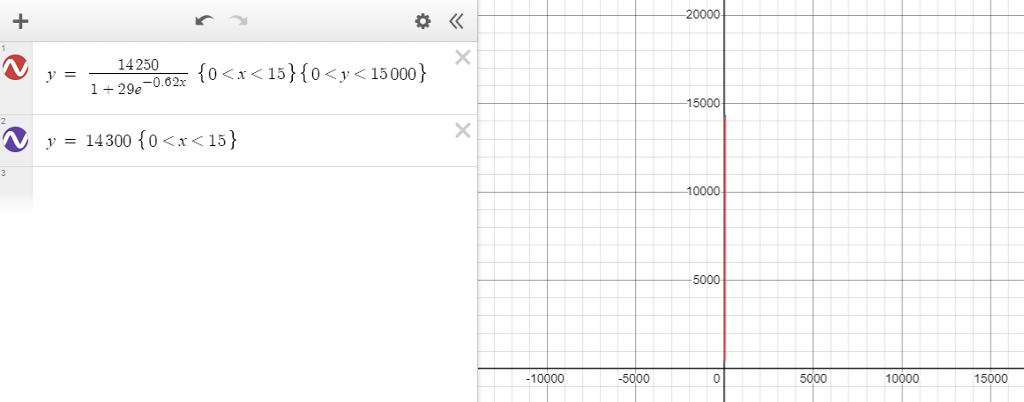

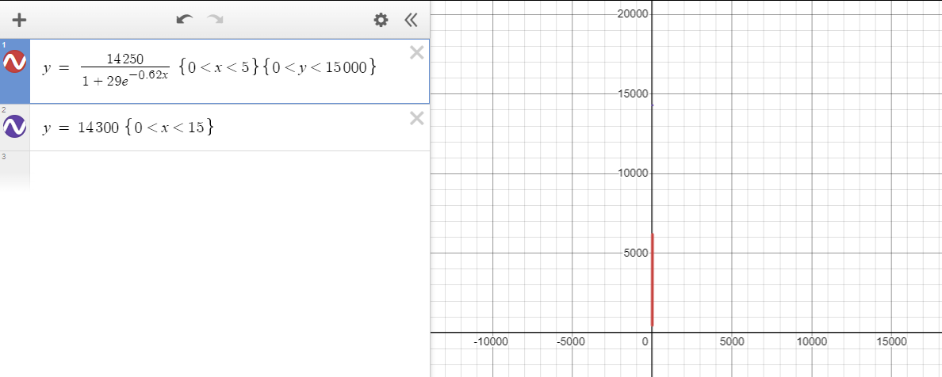

**References:**

1. Jünger, M., & Mutzel, P. (Eds.). (2012). *Graph drawing software*. Springer Science & Business Media.
2. Barbara, K. D., & Spitznagel, C. R. Creating Calculus Demos with GeoGebra 4.
3. Kastberg, S. E. (2002). *Understanding mathematical concepts: The case of the logarithmic function* (Doctoral dissertation, University of Georgia).

**The End**